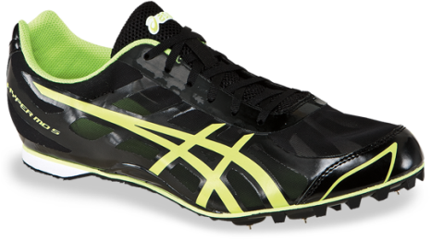 | 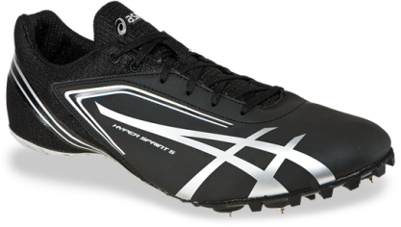 | 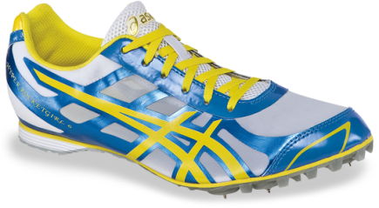
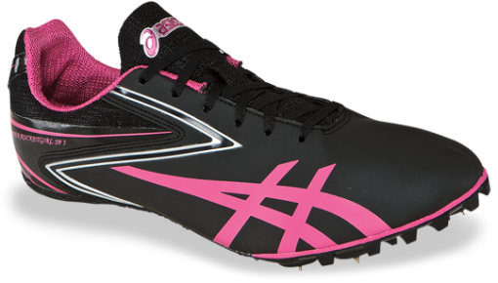 | 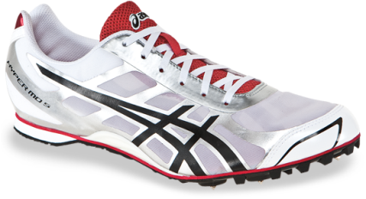 | 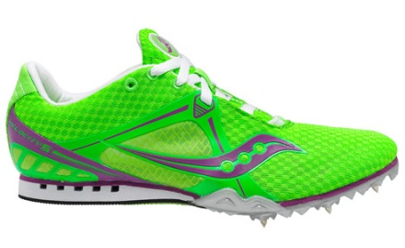
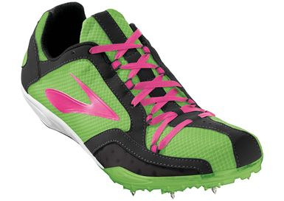 | 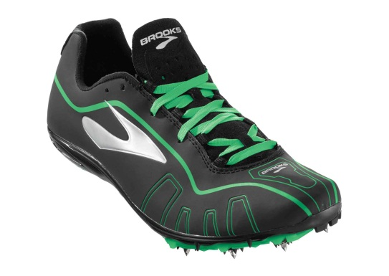 | 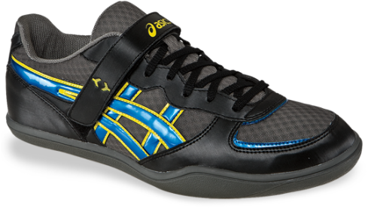
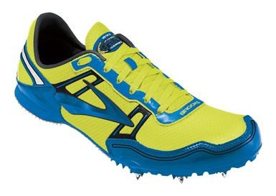 | 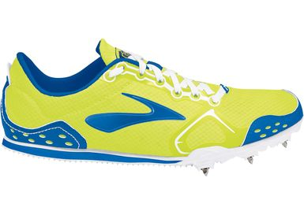 | 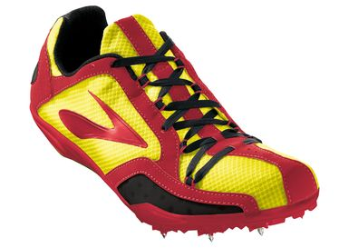
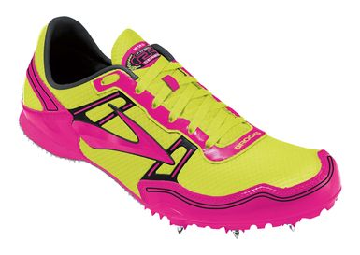 | 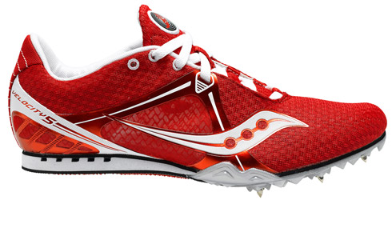 | 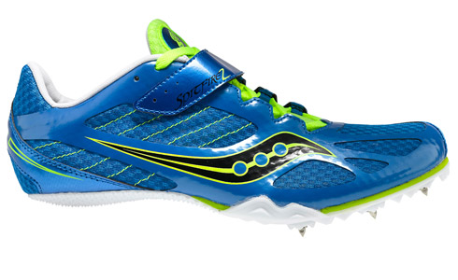
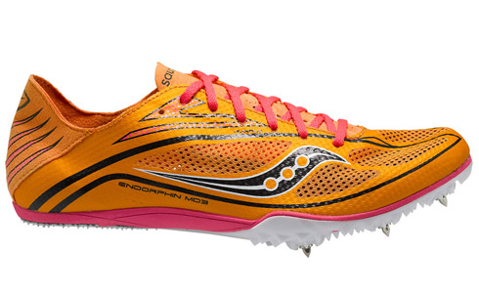 | 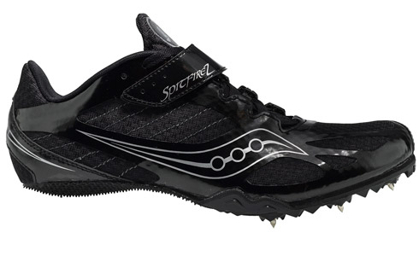 | 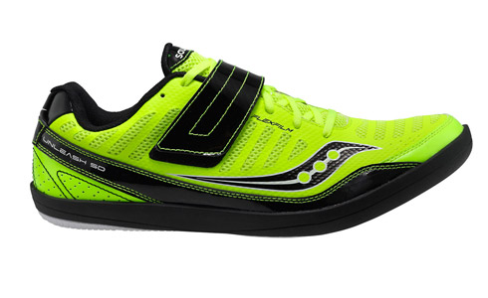

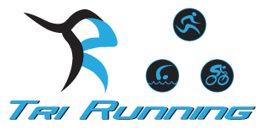

Tri Running would like to offer special Track season pricing for high school and youth club Track athletes. We pride ourselves in making sure you get in the right shoe, decreasing the chance of injury and allowing for maximum performance. We are all runners (and/or triathletes) and want to help in any way we can. Please mention what school or club you run for in order to receive this discounted pricing.
Training Footwear
$ 70, $60 and $50 specials, over 10 models to choose from, limited to stock on hand
10 % discount all other footwear + extra 10 % when buying 2 or more pairs
Racing Footwear
10% off All Spikes, Racing Flats & Waffle Racers + extra 10 % when buying 2 or more pairs (training or racing)
EXTRA SPECIAL- $ 50 for Saucony A4 racing flat- limited to stock on hand
Apparel & Accessories
25% All Apparel & Socks
20% discount on all Tifosi sunglasses, Nutritional Products, Asics/Brooks running hats, and all therapeutic products (The Stick, The Grid foam roller, etc.)
Athletes will receive a minimum of 10% off everything else in the store.

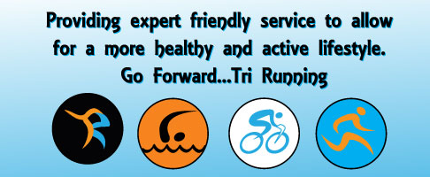
Tri Running: 2233 Ventura Blvd. Camarillo, CA 93010. 805-973-7861 www.TriRunning101.com

