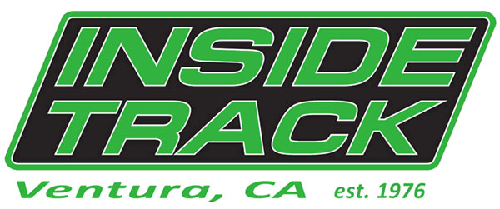 2437 Harbor Blvd. Ventura, CA 93001 * (805) 644-5555
Youth Running Shoes & Track Spike Specials
- 10% off spikes, apparel, nutrition or accessories
- 20% off shoe & spike/flat package (purchased together)*
- 30% off –50% off Clearance shoes (2 seasons or older, all sales final)
*includes spike bag (while supplies last; package deals now – 2/28/13)
Youth Running Shoes sizes Y12 –7 ~ Spikes/Flats sizes 1-7 ~ Adult sizes 5-15
Also available…Youth Shorts, Sweatshirts & Socks

Ask about Inside Track’s “I Want to Give Back” program
Inside Track has set up a “Give Back” program to help teams in our community. Donate back $1 - $5 (of your savings) to your team. No special nights, fliers or coupons necessary.
Inside Track, supporting our youth for over 35 years!

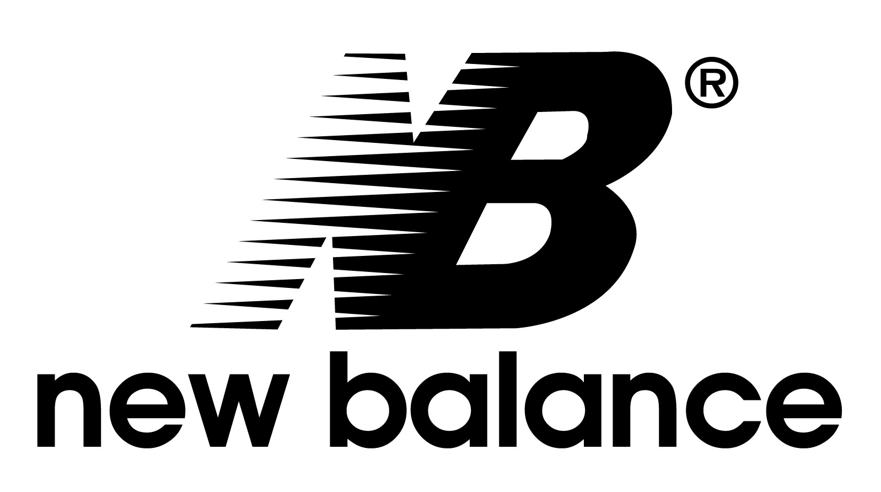
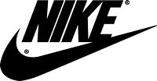
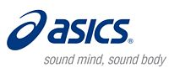

Package specials excluding Brooks and Adidas
2437 Harbor Blvd. Ventura, CA 93001 * (805) 644-5555
Youth Running Shoes & Track Spike Specials
- 10% off spikes, apparel, nutrition or accessories
- 20% of shoe & spike/flat package (purchased together)*
- 30% off –50% off Clearance shoes (2 seasons or older, all sales final)
*includes spike bag (while supplies last; package deals now – 2/28/13)
Youth Running Shoes sizes Y12 –7 ~ Spikes/Flats sizes 1-7 ~ Adult sizes 5-15
Also available…Youth Shorts, Sweatshirts & Socks

Ask about Inside Track’s “I Want to Give Back” program
Inside Track has set up a “Give Back” program to help teams in our community. Donate back $1 - $5 (of your savings) to your team. No special nights, fliers or coupons necessary.
Inside Track, supporting our youth for over 35 years!

