2019
Training Plan
Youth/Intermediate

Table of Contents
Practice schedule 3
Training Plan Overview/Definitions 4-6
Warm Up Drills 7-8
Workout Plan 9-22
Oregon Drill Description 23-24
Strength and Mobility 25-26
Plyometrics 27
Speed Development 28-29
Sprinting Mechanics 30-31
Relays 32-35
Starts 36-37
Long Jump 38-44
High Jump 45
Hurdles 46-53
Shot Put 54-57
Practice Schedule
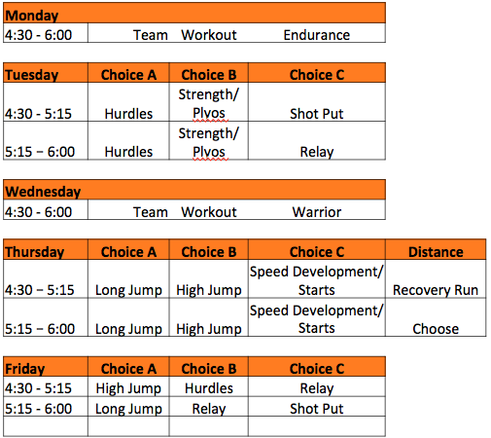
∗Gremlins practice on Tuesday/Thursday
Y/I PLAN OVERVIEW AND DEFINITIONS
This plan is a guide for planning workouts throughout the season. Because of the wide range of ability and capacity to train, there will be a need for adjustment. If there are athletes either unable to complete the workouts or complete the workout with the intended intensity/pace, the number of reps can be adjusted.
The season is broken up into three major categories: 1) early season, 2) mid season and 3) championship season. Each part of the season is meant to prepare the athletes to perform their best in the championships meets (JV Finals, Varsity Finals and beyond).
During the early season portion of the schedule, the majority of time is spent on developing aerobic capacity. A strong aerobic capacity will help enable athletes handle the anaerobic work in the later part of the season as well as develop general endurance. You’ll notice for the repetitions, the pace is slower and the rest is shorter.
The mid season is where the highest volume of work occurs as well as introducing anaerobic work (speed endurance). Intensity begins to increase, while volume hits the highest point in the season.
Finally, the championship season sees the workload decrease, providing more rest to prepare athletes to perform their best when it counts.
Sprint vs. Distance
There are some athletes who know that they only want to run sprints (400m or below) or only distance (800m or above). Both sprinters and distance runners need to develop their aerobic system. This system will continue to improve throughout adulthood.
However, those that want to concentrate on the sprint events will spend less time developing the aerobic system and instead will focus more on anaerobic (speed endurance) and speed development. The workouts will tend to be higher in intensity and lower in volume.
Distance runners will be spending much more time on aerobic system development and more time at the (T) pace (defined below).
Sprints will be divided into short sprints (those wanting to concentrate on the 100 meters and 200 meters) and long sprints (those wanting to concentrate on the 200 meters and 400 meters). Short sprinter workouts will be somewhat shorter, with higher intensity than long sprinter workouts.
Definitions:
Speed development – Workouts that are meant to recruit muscle fibers that are responsible for running at maximum speed for a very short distance. Many people consider “speed work” to be intervals or repeats such as 400 meter repeats or 200 meter repeats, etc. This is not your maximum speed.
You’ll see on most Thursdays we’ll be doing “150m in and outs”, “30 meter falling starts”, or “50 meter hill sprints” (some of these workouts are denoted with a SD). These are not meant to be tiring, but are meant to tap into your fast twitch muscle fibers and train the nervous system to use them. This is sometimes called neuromuscular training.
The reason that your basic speed matters is that it's a window into a broader continuum of paces, i.e., speeds, that you need to run to perform your best. When you improve your basic speed, you become more efficient at the other speeds you need to hit. It also helps develop better running economy or the efficiency of running and running form/technique.
Paces:
In each workout, there is a letter in parenthesis. This letter designates the pace each repetition should be run. The specific pace can be derived by several tables (i.e. Jack Daniels running formula or the McMillian running calculator) that use race times to determine the proper pace for each athlete.
Following are the definitions:
(E) or Easy pace – this is a pace that is comfortable to run. Athletes should be able to have a conversation when running easy pace. Easy running helps build the muscle system required for running and helps develop the systems within the muscles that help deliver oxygen.
(T) or Threshold pace – running at Threshold pace is where the athlete is running at maximum oxygen consumption without developing high accumulations of lactate. Threshold training helps extend the amount of time that an athlete can run in a race without accumulating high levels of lactate (know as lactic acid).
(I) or Interval pace –is a more intense pace of running. Interval pace training stresses the oxygen delivery/processing system beyond its limit. This type of training helps the muscles learn to manage oxygen deficiency and lactate processing (buffering and consumption of lactate). This helps increase speed endurance capabilities.
(R) or Repetition pace – is the pace you would run in a race or faster (can be maximum effort). The purpose of this type of training is anaerobic efficiency along with running economy.

WARM UP DRILLS
Muscles contract faster and harder when warm versus when cold. If a high level of performance in a workout or race is expected, a warm up is required. Any movements will warm the body and raise the muscles temperature, however the warm up routines chosen below are developed to match the type of workout (i.e. aerobic warm up is designed to be done before races or hard workouts) and also to be specific to running motions and that teach and develop areas essential to efficient running technique.
The drills also act as plyometric exercises, which develop power and explosion along with building strength within running motions, which also contribute to improved running economy and form.
Following are breakouts of what each Warm Up routine contains along with URLs that demonstrate them.
Lunge Matrix
This routine can be done at the start of practice, right before the running portion, or integrated into either strength or drills. *this routine can be seen at: https://www.youtube.com/watch?v=TztqW3Jum50
Sprint
- A skips 2 x 20 meters
- B skips 2 x 20 meters
- Ankling 2 x 20 meters
- Cycling 2 x 20 meters
- Fast leg right 2 x 20 meters
- Fast leg left 2 x 20 meters
- Fast leg alternating 2 x 20 meters
- Straight leg bounding 2 x 20 meters
- Bent leg bounding 2 x 20 meters
- this routine can be seen at: https://www.youtube.com/watch?v=5F71gzoZErQ&t=182s
Aerobic Work
- Forward skips (big arms) 20 meters
- Backward skips (big arms) 20 meters
- Lateral shuffle (big arms) 20 meters each direction
- Single leg squat 5 times then run out for 20 meters each leg
- Forward skips (arms across body) 20 meters
- Backward skips (arms across body) 20 meters
- Wide outs 5 times then run out for 20 meters (back and forth)
- Speed skater 5 times the run out for 20 meters (back and forth)
- Single mountain climber 5 times each leg the run out for 20 meters
- Retro running heel to butt 20 meters
- Double leg mountain climbers 5 times then run out for 20 meters
- Retro running heel to butt 20 meters
- Some of this routine can be seen at: https://www.youtube.com/watch?v=11QOuilfG8k
Stretching
There are many types and definitions of stretching. Research over the past 30 years has challenged the conventional thinking about what stretching does and what flexibility means. With the potential dangers of stretching incorrectly, as well as the limited time in Tigres, traditional post workout stretching will not be done as part of our practices.
If you absolutely feel like you must stretch, please consider doing Active Isolated Stretching during your own time. It is a method that does not involve the stretch reflex, so performance isn’t compromised and if done correctly, is much safer than traditional static stretching. To learn more, please see the following video: https://www.youtube.com/watch?v=R1gk_tHVxn4
Here is a website with links to quite a few studies related to stretching (it is primarily focused on stretching as a warm up, but much still applies in general). http://bretcontreras.com/what-does-sports-science-research-have-to-say-about-warming-up/
February 4 - 10
Week 1 – Early Season
Day | Group | Drills | Workout
Maintenance  Monday | Sprint | No Practice | Parent Meeting
 | Distance | No Practice | Parent Meeting
Warrior Wednesday | Sprint | Aerobic Work Speed Ladder +  Laying starts | 1 Mile (E), 4 x 100m strides  Purpose – Aerobic capacity
 | Distance | Aerobic | 4 Miles (E), 4 x 100m strides  Purpose – Aerobic capacity, running economy/form
T.N.T.  Thursday | Sprint | N/A | No structured team running workout. Attend Speed Development and/or Plyos, Starts recommended.
 | Distance | N/A | 3 Mile (E), 4 x 150m in and outs (SD)  Aerobic capacity, speed development, running economy/form
Saturday | Sprint | N/A | 10 Minutes (E) cross country run on your own  4 x 100m strides  Purpose – Aerobic capacity
 | Distance | N/A | 4 Miles (E) on your own  Purpose – Aerobic capacity
Quote of the week: "The will to win means nothing without the will to prepare." -Juma Ikangaa, 1989 NYC Marathon winner

February 11 - 17
Week 2 – Early Season
Day | Group | Drills | Workout
Maintenance  Monday | Sprint | Sprint | 2 laps of (100m @T, walk back 50m)  Purpose – Aerobic capacity
 | Distance | Sprint | 4 Miles (E)  Purpose – Aerobic capacity
Warrior Wednesday | Sprint | Aerobic Work  Speed Ladder +  Laying starts | 2 x 800 (T), 3 min rest between  Purpose – Aerobic capacity, teach (T) pace
 | Distance | Aerobic Work | 1600(T) 2 min rest, 4 x 400 (T) 60 sec rest  Purpose – Aerobic capacity
T.N.T.  Thursday | Sprint | N/A | No structured team running workout. Attend Speed Development and/or Plyos, Starts recommended.
 | Distance | N/A | 4 Mile (E), 4 x in and outs (SD)  Purpose - Aerobic capacity, speed development, running economy/form
Saturday | Sprint | N/A | 10 Minutes (E) cross country run on your own  4 x 100m strides  Purpose – Aerobic capacity
 | Distance | N/A | 5 Miles (E) on your own  Purpose – Aerobic capacity
Quote of the week: "There are no shortcuts to any place worth going.” Beverly Sills – Singer

February 18 – 24
Week 3 – Early Season
Day | Group | Drills | Workout
Maintenance  Monday | Sprint | Sprint +  Hurdle Mobility | 1600 (E on curves, T on straights)  Purpose – Aerobic capacity
 | Distance | Sprint | 4.5 Miles (E)  Purpose – Aerobic capacity
Warrior Wednesday | Sprint | Aerobic Work  Speed Ladder +  Laying starts | 2 x 400m(T) 90 sec rest,  4 x 200(T) 60 sec rest  Purpose – Aerobic capacity, teach (T) pace
 | Distance | Aerobic Work | 17 min Oregon Drill (80m E, 80m 3200 race pace, 80 closing speed) jog to start recovery  Purpose – Aerobic capacity, teaching pace and team work
T.N.T.  Thursday | Sprint | N/A | No structured team running workout. Attend Speed Development and/or Plyos, Starts recommended.
 | Distance | N/A | 4 Mile (E), 4 x 150m in and outs (SD)  Purpose - Aerobic capacity, speed development, running economy/form
Saturday | Sprint | N/A | 10 Minutes (E) cross country run on your own  4x 100m strides  Purpose – Aerobic capacity
 | Distance | N/A | 5 Miles (E) on your own  Purpose – Aerobic capacity
Quote of the week: "Don't bother just to be better than your contemporaries or predecessors. Try to be better than yourself." -William Faulkner

February 25 – March 3
Week 4 – Early Season
Day | Group | Drills | Workout
Maintenance  Monday | Sprint | Sprint +  Hurdle Mobility | 3 laps of (100m @T, walk back 50m)  Purpose – Aerobic capacity
 | Distance | Sprint | 4.5 Miles (E)  Purpose – Aerobic capacity
Warrior Wednesday | Sprint | Aerobic Work  Speed Ladder +  Laying starts | 1 x 800 (T) 3 min rest  1 x 400m (I) 3 min rest  2 x 200m (I) 2 min rest  Purpose – Aerobic capacity/Speed endurance
 | Distance | Aerobic Work | 2 x 800m (T) 1 min rest  4 x 400m (T) 1 min rest  2 x 200m (I) 30 sec rest  Purpose – Aerobic capacity
T.N.T.  Thursday | Sprint | N/A | No structured team running workout. Attend Speed Development and/or Plyos, Starts recommended.
 | Distance | N/A | 4 Mile (E), 4 x 150m in and outs (SD)  Purpose - Aerobic capacity, speed development, running economy/form
Saturday | Sprint |  | 10 Minutes (E) cross country run on your own  4x 100m strides
 | Distance |  | 5 Miles (E) on your own
Quote of the week: "I succeed on my own personal motivation, dedication and commitment. My Mindset is, if I’m not out there training…someone else is." - Lynn Jennings

March 4 – March 10
Week 5 – Early Season
Day | Group | Drills | Workout
Maintenance  Monday | Sprint | Sprint +  Hurdle Mobility | 3 laps of (100m @T, walk back 50m)  Purpose – Aerobic capacity
 | Distance | Sprint | 5 Miles (E)  Purpose – Aerobic capacity
Warrior Wednesday | Sprint | Aerobic Work  Speed Ladder +  Laying starts | 1 x 400 (T) 2 min rest  2 x 400m (I) 4 min rest  2 x 200m (I) 2 min rest  Purpose – Aerobic capacity/Speed endurance
 | Distance | Aerobic Work | 1 x 1200m (T) 1 min rest  4 x 400m (T) 1 min rest  4 x 200m (I) 30 sec rest  Purpose – Aerobic capacity
T.N.T.  Thursday | Sprint | N/A | No structured team running workout. Attend Speed Development and/or Plyos, Starts recommended.
 | Distance | N/A | 4 Mile (E), 4 x 150m in and outs (SD)  Purpose - Aerobic capacity, speed development, running economy/form
Saturday | Practice Meet @ Buena High School
Quote of the week: "Whether you believe you can or believe you can't, you're probably right." -Henry Ford

March 11 - 17
Week 6 – Early Season
Day | Group | Drills | Workout
Maintenance  Monday | Sprint | Sprint +  Hurdle Mobility | 8 x 200m (T) 90 sec rest  Purpose – Aerobic capacity
 | Distance | Sprint | 5.5 Miles (E)  Purpose – Aerobic capacity
Warrior Wednesday | Sprint | Aerobic Work  Speed Ladder +  Laying starts | 2 x 300 (T) 2 min rest between  4 x 200m (I) 3 minute rest  Purpose – Aerobic capacity/Speed endurance
 | Distance | Aerobic Work | 20 min Oregon Drill (80m E, 80m 3200 race pace, 80 closing speed) jog to start recovery  Purpose – Aerobic capacity, teaching pace and team work
T.N.T.  Thursday | Sprint | N/A | No structured team running workout. Attend Speed Development and/or Plyos, Starts recommended.
 | Distance | N/A | 5 Mile (E), 4 x 150m in and outs (SD)  Aerobic capacity, speed development, running economy/form
Saturday | Meet – Heritage Valley Blazers @ Fillmore High School
Quote of the week: "Racing teaches us to challenge ourselves. It teaches us to push beyond where we thought we could go. It helps us to find out what we are made of. This is what we do. This is what it's all about." -PattiSue Plumer, U.S. Olympian

March 18 - 24
Week 7 – Mid Season
Day | Group | Drills | Workout
Maintenance  Monday | Sprint | Sprint +  Hurdle Mobility | 8 x 200m (T) 90 seconds rest  Purpose – Aerobic capacity
 | Distance | Sprint | 5.5 Miles (E)  Purpose – Aerobic capacity
Warrior Wednesday | Sprint | Aerobic Work  Speed Ladder +  Laying starts | 4 x 300 (i), 4 min rest between  Purpose – Speed endurance
 | Distance | Aerobic Work | 1 x 800m (T) 1 minutes rest  2 x 600m (T) 1 minutes rest  2 x 400m (I) 2 minutes rest  2 x 200m (I) 1 minute rest  Purpose – Aerobic capacity/Speed endurance
T.N.T.  Thursday | Sprint | N/A | No structured team running workout. Attend Speed Development and/or Plyos, Starts recommended.
 | Distance | N/A | 5 Mile (E), 4 x 150m in and outs (SD)  Purpose - Aerobic capacity, speed development, running economy/form
Saturday | Meet – Oxnard Stars @ Oxnard High School
Quote of the week: "Mental will is a muscle that needs exercise, just like the muscles of the body." -Lynn Jennings

March 25 – 31
Week 8 – Mid Season
Day | Group | Drills | Workout
Maintenance  Monday | Sprint | Sprint +  Hurdle Mobility | 3 laps of (100m @T, walk back 50m)  Purpose – Aerobic capacity
 | Distance | Sprint | 6 Miles (E)  Purpose – Aerobic capacity
Warrior Wednesday | Sprint | Aerobic Work  Speed Ladder +  Laying starts | 6 x 200 (I) 3 min rest between  Purpose – Speed endurance
 | Distance | Aerobic Work | 4 x 800 (T) 90 seconds rest  2 x 200 (I) 1 minute rest  Purpose – Aerobic capacity/Speed endurance
T.N.T.  Thursday | Sprint | N/A | No structured team running workout. Attend Speed Development and/or Plyos, Starts recommended.
 | Distance | N/A | 5 Mile (E), 4 x 150m in and outs (SD)  Purpose - Aerobic capacity, speed development, running economy/form
Saturday | Meet – Thousand Oaks @ Buena High School
Quote of the week: "Running is a big question mark that's there each and every day. It asks you, 'Are you going to be a wimp or are you going to be strong today?'" - Peter Maher, Canadian marathon runner

April 1 – April 7
Week 9 – Mid Season
Day | Group | Drills | Workout
Maintenance  Monday | Sprint | Sprint +  Hurdle Mobility | 8 x 200m (T) 90 seconds rest  Purpose – Aerobic capacity
 | Distance | Sprint | 6 Miles (E)  Purpose – Aerobic capacity
Warrior Wednesday | Sprint | Aerobic Work  Speed Ladder +  Laying starts | 3 x [300m (I) 1 min rest, 100m (I)]  Complete rest between each set  Purpose – Speed endurance
 | Distance | Aerobic Work | 6 x 400m (T) 45 sec rest  4 x 200m (I) 1 minutes rest  Purpose – Aerobic capacity, speed endurance
T.N.T.  Thursday | Sprint | N/A | No structured team running workout. Attend Speed Development and/or Plyos, Starts recommended.
 | Distance | N/A | 5 Mile (E), 4 x 150m in and outs (SD)  Purpose - Aerobic capacity, speed development, running economy/form
Saturday | Meet – Moorpark Striders @ Moorpark High School
Quote of the week: "Ask yourself: 'Can I give more?' The answer is usually: 'Yes'." -Paul Tergat, Kenyan professional marathoner

April 8 - 14
Week 10 – Mid Season
Day | Group | Drills | Workout
Maintenance  Monday | Sprint | Sprint +  Hurdle Mobility | 8 x 200m (T) 90 seconds rest  Purpose – Aerobic capacity
 | Distance | Sprint | 6 Miles (E)  Purpose – Aerobic capacity
Warrior Wednesday | Sprint | Aerobic Work  Speed Ladder +  Laying starts | 2 x [400m (I) 1 min rest, 100m (I)]  Complete rest between each set  Purpose – Speed endurance
 | Distance | Aerobic Work | 1 x 400m (I) 90 seconds rest  1 x 800m (I) 3 minutes rest  1 x 1200m (I) 4 minutes rest  1 x 800m (I) 3 minutes rest  2 x 200m (I) 1 minute rest  Purpose – Speed endurance
T.N.T.  Thursday | Sprint | N/A | No structured team running workout. Attend Speed Development and/or Plyos, Starts recommended.
 | Distance | N/A | 5 Mile (E), 4 x 150m in and outs (SD)  Purpose - Aerobic capacity, speed development, running economy/form
Sat/Sun | Southern Californian Youth Invitational
Quote of the week: "Success is the sum of small efforts, repeated day in and day out" -Robert Collier, Author

April 15 - 21
Week 11 – Mid Season
Day | Group | Drills | Workout
Maintenance  Monday | Sprint | Sprint +  Hurdle Mobility | 6 x 200m (I) 3 minutes rest  Purpose – Speed endurance
 | Distance | Sprint | 6.5 Miles (E)  Purpose – Aerobic capacity
Warrior Wednesday | Sprint | Aerobic Work  Speed Ladder +  Laying starts | 2 x 400 (I) + 50 meters all out  Complete rest  Purpose – Speed endurance
 | Distance | Aerobic Work | 25 min Oregon Drill (80m E, 80m 3200 race pace, 80 closing speed) jog to start recovery  Purpose – Aerobic capacity, teaching pace, team work
T.N.T.  Thursday | Sprint | N/A | No structured team running workout. Attend Speed Development and/or Plyos, Starts recommended.
 | Distance | N/A | 5 Mile (E), 4 x 150m in and outs (SD)  Purpose - Aerobic capacity, speed development, running economy/form
Saturday | Meet – Camarillo Cosmos @ Buena High School
Quote of the week: "It's supposed to be hard. If it wasn't hard, everyone would do it. The hard...is what makes it great!"-Tom Hanks in A League of Their Own

April 22 - 28
Week 12 – Championship Season
Day | Group | Drills | Workout
Maintenance  Monday | Sprint | Sprint +  Hurdle Mobility | 8 x 100m (I) I minute rest  Purpose – Speed endurance
 | Distance | Sprint | 6 Miles (E)  Purpose – Aerobic capacity
Warrior Wednesday | Sprint | Aerobic Work  Speed Ladder +  Laying starts | 3 x [400m (I) 1 minute rest, 100m (I)]  Complete rest between each set  Purpose – Speed endurance
 | Distance | Aerobic Work | 4 x 400m (I) 2 minutes rest  3 x 300m (I) 90 seconds rest  4 x 200m (I) 1 minute rest  Purpose – Speed endurance
T.N.T.  Thursday | Sprint | N/A | No structured team running workout. Attend Speed Development and/or Plyos, Starts recommended.
 | Distance | N/A | 5 Mile (E), 4 x 150m in and outs (SD)  Purpose - Aerobic capacity, speed development, running economy/form
Saturday | Meet- Newbury Park @ Buena High School
Quote of the week: "I'm going to work so that it's a pure guts race at the end, and if it is, I am the only one who can win it." -Steve Prefontaine

April 29 – May 5
Week 13 – Championship Season
Day | Group | Drills | Workout
Maintenance  Monday | Sprint | Sprint +  Hurdle Mobility | 10 x 75m (I) I minute rest  Purpose – Speed endurance
 | Distance | Sprint | 5 Miles (E)  Purpose – Aerobic capacity
Warrior Wednesday | Sprint | Aerobic Work  Speed Ladder +  Laying starts | 2 x 500 (I)  Complete rest  Purpose – Speed endurance
 | Distance | Aerobic Work | 2 x 800m 5 minutes rest  1st at 10 seconds over PR pace  2nd at best effort  Purpose – Speed endurance, race simulation
T.N.T.  Thursday | Sprint | N/A | No structured team running workout. Attend Speed Development and/or Plyos, Starts recommended.
 | Distance | N/A | 4 Mile (E), 4 x 50m hill sprints (SD)  Purpose - Aerobic capacity, speed development, running economy/form
Saturday | League Finals @ Heritage Valley

Quote of the Week: "Every morning in Africa a gazelle wakes up. It knows it must move faster than the lion or it will not survive. Every morning a lion wakes up and it knows it must move faster than the slowest gazelle or it will starve. It doesn't matter if you are the lion or the gazelle, when the sun comes up, you better be moving." – Maurice Greene, US Sprinter

May 6 - 12
Week 14 – Championship Season
Day | Group | Drills | Workout
Maintenance  Monday | Sprint | Sprint +  Hurdle Mobility | 10 x 75m (I) I minute rest  Purpose – Speed endurance
 | Distance | Sprint | 3 Miles (E)  4 x 400 (T) 1 minute rest  Purpose – Aerobic capacity
Warrior Wednesday | Sprint | Aerobic Work  Speed Ladder +  Laying starts | 2 x 300 (I) complete rest  Purpose – Speed endurance
 | Distance | Aerobic Work | 15 min Oregon Drill (80m E, 80m 3200 race pace, 80 closing speed) jog to start recovery  Purpose – Aerobic capacity, teaching pace, teamwork
T.N.T.  Thursday | Sprint | N/A | No structured team running workout. Attend Speed Development and/or Plyos, Starts recommended.
 | Distance | N/A | 2 Miles (E)  4 x 100m strides  Purpose - Aerobic capacity, speed development, running economy/form
Saturday | VCYTC Championships @ Moorpark High School
Quote of the week: "The will to win means nothing without the will to prepare." -Juma Ikangaa, 1989 NYC Marathon winner (repeat from week 1)

May 13 - 19
Week 15 – Championship Season
Day | Group | Drills | Workout
Maintenance  Monday | Sprint | Sprint | 2 laps of (100m @T, walk back 50m)  Purpose – Aerobic capacity
 | Distance | Sprint | 5 Miles (E)  Purpose – Aerobic capacity
Warrior Wednesday | Sprint | Aerobic Work  Speed Ladder +  Laying starts | 4 x 200m (T), 4 min rest between  4 x 30m falling starts  Purpose – Aerobic capacity, speed development
 | Distance | Aerobic Work | 4 x 400m (I) 2 minutes rest  2 x 200m (I) 1 minute rest  Purpose – Speed endurance
T.N.T.  Thursday | Sprint | N/A | No structured team running workout. Attend Speed Development and/or Plyos, Starts recommended.
 | Distance | N/A | 2 Miles (E)  4 x 100m strides  Purpose - Aerobic capacity, speed development, running economy/form
Saturday | Co Conference Championship Meet @ Moorpark
Quote of the week: "A lot of people run a race to see who is fastest. I run to see who has the most guts, who can punish himself into exhausting pace, and then at the end, punish himself even more. Nobody is going to win a 5,000 meter race after running an easy 2 miles. Not with me. If I loose forcing the pace all the way, well, at least I can live with myself." – Steve Prefontaine

OREGON DRILL
The Oregon Drill is used for several reasons during the Tigres track season.
- It combines work on both aerobic and anaerobic energy systems.
- Teamwork and running as a team is reinforced.
- Running on the infield creates a break from the stress of running on the track.
- It eliminates traffic on the track.
- Changing speeds during races is simulated.
- It is a way for coaches to have the ability to monitor all groups at the same time
- Below is the description by Pat Tyson from Mead High School in Washington. 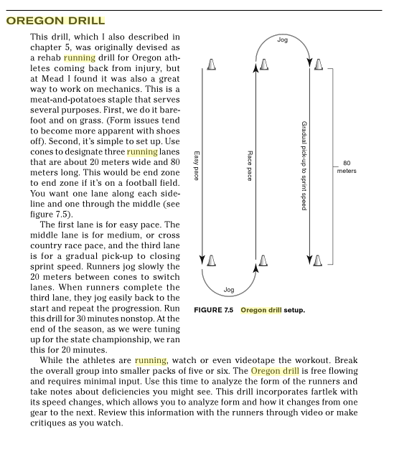
STRENGTH AND MOBILITY
Whether the athlete is a sprinter or distance runner, becoming a better athlete (stronger and more explosive) will not only help performance, but will also help greatly in preventing injury, improving running economy (form and technique), and will increase the athlete’s ability to do more work.
Historically, when doing this type of work, athletes have focused on strengthening and creating flexibility in specific muscles (i.e. stretching a hamstring or doing a hamstring exercise). Current beliefs are moving towards training movements or creating strength and flexibility within a range of motion specific to the sport (in this case running).
Core
https://vimeo.com/9807775
- Prone Elbow Stand
- Running V-Sit
- Lateral Plank Left
- Back Hyper and flutter kick and crawl with arms
- Lateral Plank Right
- Flutter Kick V-Sit
- Back Hyper Scissor Breaststroke
- Indian Sit Crunches
- Scissor over/under V-Sit

Hip Mobility
- Iron cross
- Donkey kicks
- Scorpion
- Donkey whips
- Hurdle seat exchange
- Knee circle

Bruin – Medball
http://www.uclabruins.com/fls/30500/old_site/pdf/m-track/braden.pdf?DB_OEM_ID=30500
- Push ups
- Christian Smith Drill
- Russian Twist
- Burpees
- Medball Bridge – (advanced optional)
- Medball Pushup (changing hands)
- Medball Squats
- Push ups
- Burpees

The number of repetitions, sets or time should be increased as the season goes on as well as be adjusted to the capability of the athletes.

PLYOMETRICS
The most important factors in determining jumping and sprinting performances is the ability to quickly apply forces to the ground. Previous research has shown that faster runners can apply greater amounts of force down into the ground during the brief ground contact period than slower runners. This high rate of vertical force application leads to shorter ground contact times as well as longer stride lengths, thus allowing the faster runners to attain greater maximum speeds.

What many fail to realize is that gains in strength can only be transformed into power by applying very specific power training methods. For decades it has been probable that one of the most successful methods of training is the employment of plyometric exercises.

Also known as reactive training, the stretch – shortening cycle, or stretch reflex. The exercises known popularly as plyometric are those in which the muscle is loaded in an eccentric (lengthening) contraction, immediately followed by a concentric (shortening) contraction. It has been demonstrated that a muscle that is stretched or pre-tensed before a contraction will contract more forcefully and rapidly. What many fail to realize is a third type of force known as isometric which occurs just before touchdown of the foot before the eccentric contraction, and again at full support just before the concentric contraction.
Plyometric Routine
- Straight leg bound regular bound
- Single leg straight leg bound RT. right-right-left-left
- Single leg straight leg bound lft.
- Lunge jumps
- Power skips frog hops
- Backwards Paw Sprint
- Side shuffle bound
- Single leg hop right
- Single leg hop left

SPEED DEVELOPMENT
The goal of a speed-development workout is simply to "call on" the fibers that aren't recruited in large numbers when jogging or even running threshold or race pace. The improved coordination between your metabolic system and bodily mechanics from these workouts will result in faster, more efficient running at other effort levels.
150 In and Outs
On a 150m run, accelerate gradually during the first 50m; then run the middle 50m at your maximum speed, then cruise out of that rhythm the last 50m.

Start with three to four of these and work up to six to eight with each middle 50m getting a bit faster. Don't worry about anything other than the pace of the middle 50m.

Take as much rest as you want, as the intent of this workout is not to endure anything, but rather to recruit more fibers. You gain nothing by speeding up the recovery. You are not recovered enough until you can successfully run the middle 50m at your absolute maximum speed. We want that middle 50m patch to be your maximum speed, while still running controlled and relaxed in your neck and shoulders.
30 Meter Max Patch
Once you've done several weekly sessions of 150 In-n-Outs, you can progress to this workout. To start, you'll do three to four of the 150m In-n-Outs. Then you'll run 2-3 x 30m at 97 percent; though technically you're not running at your maximum, most people will actually run a bit faster with the cue of "97 percent" rather than "all-out" or "as fast as you can" because they will stay more relaxed in their neck, face and shoulders.

The recovery is 2-3 minutes walking. Yes, walking. Running 30m at 97 percent is metabolically powered by the phosphocreatine system, and 3 minutes of walking will allow that system to replenish nearly all of ATP needed for the next 30m sprint.

Speed Ladders

- In and out steps
- Lateral shuffle
- Side laterals
- Forward hop
- Siderocker
- Icky shuffle
* this routine can be seen at: http://www.youtube.com/watch?v=sOAA-_lGyUw and http://www.youtube.com/watch?v=7RHVnGwoU1E&NR=1&feature=fvwp

SPRINTING MECHANICS
Head
- Keep your head still and naturally in line with your spine
- Relax your jaw and neck muscles
- Focus your eyes down the track

Shoulders
- Relax your shoulders to keep from shrugging, which will lock your hips
- Power upper-body movement with your shoulders, not your arms

Arms/Hands
- Balance leg movements with your arms; the arm on your lead leg side should go back, and vice versa
- Swing your arms forward to a closed place at a 135-degree angle in front of your body and backward to an open place behind your body. Bringing your arms too far forward or backward will throw off your balance and waste energy
Posture
- Maintain a neutral posture. A forward or backward tilt at the pelvis will decrease range of motion in the hips, adding injury- causing pressure to the hamstrings
Front-Side Mechanics
- Raise your lead leg to a locked horizontal position with your hips held high
- Adjust the angle between your shin and foot to 90 degrees or more
- To start a forward swing, extend your lead leg at the knee
- Prepare for contact by stabilizing your ankle and keeping your toes up
- Land with a flat, mid-foot strike
- Swing your landing leg two to four inches in front of the hip to apply force on contact. If you swing too far, your body will naturally brake. If you don’t swing far enough, you’ll lose stability.

Back-Side Mechanics

- Start back-side mechanics when your recovery leg is even with your support leg on ground contact
- Keep your hips tall
- Contact the ground with your foot bent toward your body, and push off with your toes
- Bring your toes off the ground with your ankle bent toward your body under the gluteal muscle
- Shorten your recovery leg as it goes up and over the knee on your support leg and rises to a locked position; think of the cyclical motion of a pedaling bike; bring your heel as high as possible, up over your support leg knee

RELAYS (4 x 100)
The goal for Tigres is to teach relay fundamentals so that each year athletes will become more proficient. The following guide lays out the basic fundamentals that we will follow to give coaches and athletes a foundation for learning relays in a consistent way.
Relay Zone Definitions
10 yards from the small triangle to large triangle is the acceleration zone.
20 yards from large triangle to large triangle is the relay zone or exchange zone
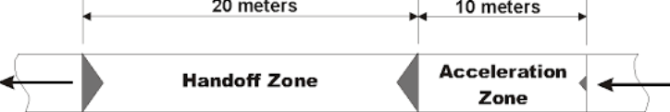
Baton must be handed off between the 2 large triangles or in the relay zone
Midget/Youth/Int to use acceleration zone (small triangle)
Bantams to be taught the acceleration zone and coaches will determine which athletes are capable of using and when they should transition to using.
Outgoing runner can never step behind the small triangle once the starting gun is fired. Entire foot must be in front of the small triangle or runner will be disqualified.
How To Determine Marks
6 strides (18ft) to be used to set first mark for runners 2, 3, and 4 (this will likely be adjusted)
Mark to be set on opposite side of the lane (ex: runner 2 runs on the outside of lane, so mark will be set on inside of the lane)
Second mark will be set 1 long stride past the first mark
First mark (18ft) will be set if both runners are the same speed (adjust the mark closer if incoming runner is slower and longer if incoming runner is faster)
Second mark will always be 1 long stride, regardless of speed
Outgoing runner takes off at full speed when incoming runner steps between the first and second mark (each runner stays on their side of the lane)
Guidelines For Choosing Legs
Runner/Leg 1:
- Fast starter
- Runs turns well
- Stays on inside of lane
- Carries baton in right hand
- Only needs to hand off baton
Runner/Leg 2:
- Runs longest distance
- May want fastest runner in this position
- Stays on outside of lane
- Carries baton in left hand
- Needs to receive baton and hand off baton

Runner/Leg 3:
- Runs turns well
- May want slowest runner here
- Stays on inside of lane
- Carries baton in right hand
- Needs to receive baton and hand off baton
Runner/Leg 4:
- Strong finisher (gamer/highly competitive)
- Stays on outside of lane
- Carries baton in left hand
- Only needs to receive baton
Advanced Strategy
In a perfect scenario, all four runners will have close to the same speed. In this case, a coach may put the fastest runner as the anchor. However, this is seldom the case.
Where there is a difference in speed, the fastest runner should be number 2 to maximize the distance they run (up to 110 – 120 meters). This is accomplished by receiving the baton early in zone 1 and passing of late in zone 2.
If you have a weaker runner, it is typically best to put them on leg 3 to have them run the shortest distance (leg 2 hands of late and leg 4 receives early).

Notes
- Underhand pass to be used in all age groups
- Hand off happens when runners are almost side by side
- Carry baton at the bottom to create more room for receiving runner to grab
- Learn to adjust the baton (wiggle hand down) while running full speed
- Never switch hands with baton during the 4 x 100
- Call “stick” only when 1 stride away (approximately 3-4 feet)
- Incoming runner runs through the hand off and stays in lane
- Outgoing runner never looks back during the exchange
- Both incoming and outgoing runners should be running at full speed during exchange
- Both incoming and outgoing runners must stay in their lane until the race is over
- Where the baton is, determines before and after the zone, not the runner
- Either tape or a tennis ball cut in half can be used as markers
- Finishing runner must not throw the baton after the race or the team will be disqualified
- When starting (runner number 1), the baton can hang over the starting line, but fingers must remain behind the starting line

STARTS

How To Set Blocks
- Front black pad is set 2 feet from start line
- This will be your “power” leg or jumping leg
- Back block is set 3 feet from the start line
- This will be your “speed” leg (kicking leg)
Positions At Starters Commands
- Stay loose behind the blocks (no stretching)
On “Marks” Command By Starter:
- Walk from behind blocks past starting line and loosen legs.
- Don not “show boat” (draw attention to yourself), but take 3-4 seconds and proceed back to blocks
- Put hands on track and back into block: front pedal first
- Heels off pedal, toes curled under
- Position hands behind starting line with fingers together
- Create bridge with thumb and fingers (fingers parallel to start line)
- Rock forward until shoulders are over hands, elbows locked
- Drop head
- Remain still

On “Set” Position By Starter
- Raise hips with front knew 90 degrees, back leg at 120 degres
- Come up steadily
- Toe on track on front foot
- Utilize the back leg to lift hips
- Put pressure on both blocks
- Relax front leg
- Concentrate on back pedal
- Look downward at the track
- Relax neck
- Don’t raise head
- Remain still and relaxed
At The “Gun”
- Push off with both feet (try to move block)
- Drive arm of power leg forward
- Take a long, low, powerful fist stride
- Gradually lengthen stride through acceleration process
- Gradually work your way to sprint posture – this should take at least 20 meters

LONG JUMP
Concept Videos
Below are you videos that are a good introduction into long jump and some of the drills we use.
- Long jump Cameron Gary basic
https://www.youtube.com/watch?v=p1Lbskr-vbQ
- Chair drill
https://www.youtube.com/watch?v=-A8632_Nx6k
- Chair drill to pit
https://www.youtube.com/watch?v=ChCIKwDB4aw
- Landing while using standing long jump
https://www.youtube.com/watch?v=R8YIHpD8tn8
- Teaching the hang
https://www.youtube.com/watch?v=-ulr1CQC8LY&list=PLA81F86E0A628DE18&index=2
- Box drills
https://www.youtube.com/watch?v=C08RAUZYWVw&list=PLA81F86E0A628DE18&index=4
- Box taps/bench drives
https://www.youtube.com/watch?v=BDdO27eAINQ

Long jump warm-up drills
- Low skips with the big arms
- Lateral jacks
- A skips
- B skips
- C skips
- Hip twists
- Skipping for height
- Straight leg bounding (then run it out)
- Hip rotations
- Knee rotations
- Ankle rotations
- Frog hops
The Approach Run Up
The objective of the approach run is for the athlete to achieve the ideal speed – fast and controlled. The length of approach depends on age, strength, and experience. Jumpers should reach maximum speed when they hit the board. If an athlete is slowing down before reaching the board, the approach should be shorter. As a starting point with beginning jumpers think 5 lefts or rights or 10 total steps and go up or down from there based on competence. This distance should be measured away from the runway. Have them start at a fixed point on the track, accelerate and run through whatever number of steps you have determined as a starting point (5 or 6 lefts or rights). Mark where the takeoff foot lands on 6 approaches. Use the most frequent spot they hit and measure back to your starting point. A couple of reminders, do not have them takeoff when running these approaches. When you add the penultimate and takeoff step, the approach will be longer, maybe a few inches. The athlete should know the distance of their approach and never have to “run it back” at a meet; this reflects lack of preparation. It is easier to count lefts or rights than total steps, so count takeoff leg steps.
What foot does the athlete takeoff with? Generally, this is the preferred leg for doing a lay up in basketball, the foot they would generally put forward to start with and the opposite of their handedness (right handed = left foot takeoff). There are exceptions to the rule…, so try both feet if you’re unsure. Another method is to have the athlete fall forward. The foot which falls first should be their drive leg and the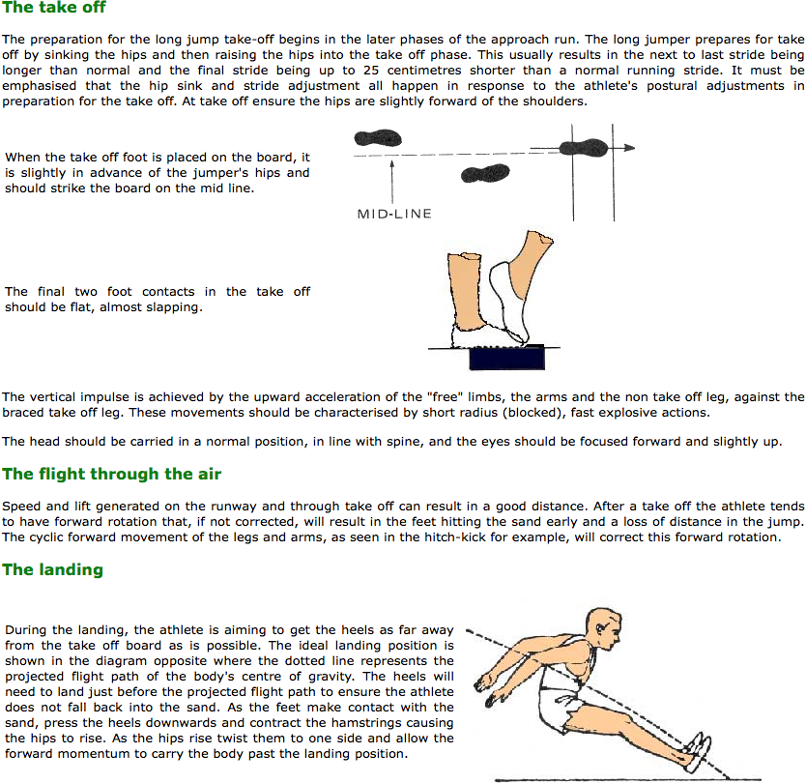 other should be the take-off leg.
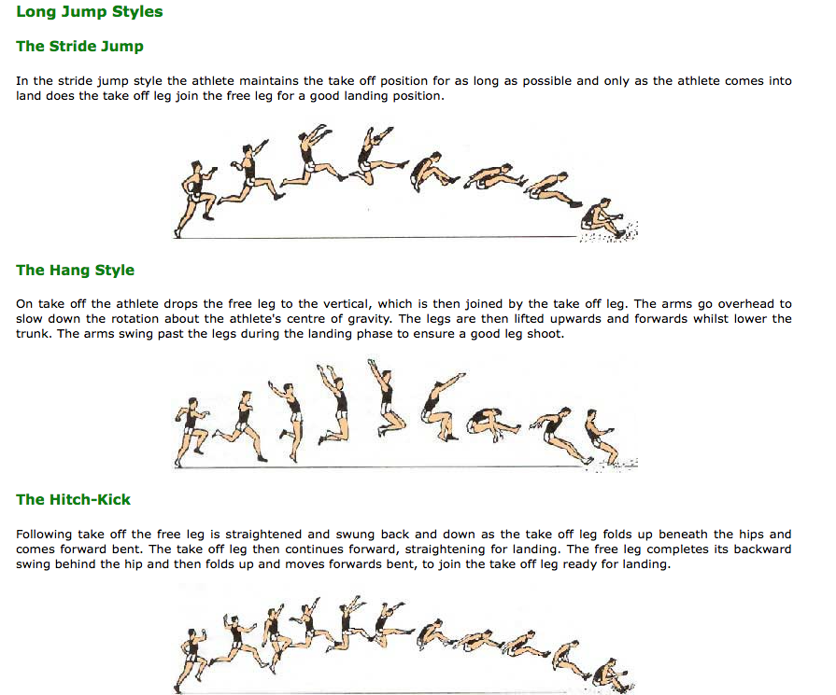
Early Season (Weeks1-5)
During weeks 1-5 the athlete will learn
- Starting foot and take-off foot preference
- Number of strides (resulting in a mark) for approach
- Drive off the board
- Landing with two feet
- Exiting the pit

Mid Season (Weeks 6-10)
During weeks 6-10 the athlete will
- Continue practicing full approach becoming more consistent with approach
- Introduce the penultimate
- Continue working on drive and flight
- Focus on driving through feet during landing

Championship Season (Weeks 11-14)
During weeks 11-14 the athlete will
- Continue practicing full approach
- Continue practicing penultimate
- Continue working on take-off/flight/landing

HIGH JUMP
High Jump Practice Routine
Tuesday
Station One- Small Pits
- Back-overs using the bungie to warm up. Use bench or wooden block to work on arch.
- Four step approach focusing on technique. Still use the bungie.
Station Two- Drills
- Use wooden blocks with speed hurdles with some cones to do drills.
(More research needed to add more types of helpful plyos)

Station Three- Big Pits
- Back-overs, only for the first group, to warm up. Use bench or wooden block and better work on getting an arch.
- Work on run-thrus.
- Once mark is established, alternate between run thru and full run and jump.
- Depending on the size of group, 3-5 consecutive jumps per jumper
Friday
- Focus on getting a measured mark.
- Mainly practice on run-thrus.
- Limited jumps.

HURDLES
Take Off Mechanics
- Lead with the Knee
- Don’t lead with the foot.
- Watch to Wallet
- Lead arm thumb turned down and to the forehead or above for men.
- Lead arm thumb turned down and to the mouth or above for women.
- Stay Square
Flight Mechanics
- Stay tight
- Hurdle through the window
- Knee should be bent, not straight.
- Chest over thigh
- Toe down...go down
- Evert the toe to ensure clearance of the hurdle and put foot into better position to run off the hurdle.
Coming Off the Hurdle
- Active lead leg
- As soon as the front foot crossed the hurdle it should move toward the ground.
- The back arm waits at the hip and races the lead leg through the hurdle.
- Sweep the arm back
- The trail leg will be tight to the body moving into the arm pit.
- The arm needs to sweep back accordingly to make room for the trail leg.
- Do not swing wide!!!
- Push your shoulders up”
- Don’t stand up too early.
- Wait until the trail leg goes through the hurdle.
Get-Away Stride
- KEEP RUNNING!!!
- No Bounding
- After the first hurdle the athlete’s eyes should be up looking at the next hurdle.
The key to teaching hurdling to young athletes is repetition. Constant repetition over a few hurdles, day after day, gives the best results.
Beginning
Using non-weighted or scissors hurdles that can adjust down to 46 cm. (1 ft., 6 in.) in height, set up four lanes of hurdles with the following heights and spacing (Table 1).
Each flight should have three or four hurdles. As many as 20 or more hurdlers can be training at the same time using this method.
lane 3 | 46 cm. height | 11 m. to first hurdle | 8 m. between hurdles
lane 4 | 53 cm. height | 11 m. to first hurdle | 8.7 m. between hurdles
lane 5 | 61 cm. height | 11 m. to first hurdle | 9.5 m. between hurdles
lane 6 | 69 cm. height | 12 m. to first hurdle | 10.2 m. between hurdles

Sample Table 1 – should be adjusted for different age groups or experience level
Instruct the athletes to run with an exaggerated knee lift over the lane 3 hurdles taking five steps between the hurdles. It doesn't matter how big or small the athlete is, they start with lane 3. If the athlete is already familiar with hurdling then he would go on to a more difficult lane.
In all likelihood, the athletes will initially run and jump, run and jump. Therefore constant emphasis must be placed on stepping over the hurdles and running with high knees over the hurdles.
Also, instruct the athletes to clear the trailing leg by lifting the knee high and out to the side under the arm with the knee in a higher position than the foot. The action of the lead leg is quite different; the knee is driven high in front of the chest toward the hurdle with the foot being snapped up just high enough to clear the hurdle.
Stride length at this time should be fairly short (five steps between the hurdles) concentrating on rhythm and not speed. As the athletes warm up and are able to do the first lane with ease, instruct them to move to the next lane, progressively running faster.
The athletes also are likely to stop in front of each hurdle and hop over with considerably diminished speed. Correct this by instructing them to go forward not up over the hurdles.
The hurdlers should do six to twelve flights of hurdles at each workout. As they improve, they can progress to the next higher hurdle flight. Most hurdlers do well to warm up with a couple of flights with the smallest hurdles even though they may have progressed to the higher heights.
In this way, the rhythm is easily learned and the tendency to jump over the hurdles is diminished, especially by the sixth or eighth flight when the hurdler's legs are too tired to jump. It is also important for the hurdler to run 10 meters past the last hurdle to get used to the finish of the race.
The hurdlers will probably begin running over the hurdles slowly to start with but should start running faster as they gain confidence and rhythm. They should be encouraged to run fast or sprint over the hurdles as the objective of the event is to get to the finish line as fast as possible. Even when warming up over the smaller hurdles, the hurdler should move his feet very fast. The hurdle race is basically a sprint race and this should be continually emphasized.
There is a great tendency for athletes to swing the lead leg up over the hurdle, much as a high jumper gets extra lift by vigorously swinging up his lead leg. The effect is the same. The athlete will lift up into the air and float over the hurdle thereby interrupting the running rhythm and slowing the athlete down. If this is a problem, have the athlete temporarily use one hurdle and concentrate on driving the knee of the lead leg towards the hurdle using a fast, flicking action of the lead foot to clear the hurdle and snap the foot back down to the track.
This must be constantly repeated until the action is learned and then have the athlete return to running hurdle flights. Also continually emphasize the use of a very high knee action to clear the trail leg. If there is a lot of difficulty teaching these two points, use the lead leg and trail leg exercises as described in Single-Leg Exercises below.
Driving quickly forward over the hurdles should be emphasized as should stepping not jumping over the hurdles
Improvement
After a few weeks of practice, the hurdlers should be ready for two actions necessary to increase the speed of hurdle clearance: leaning towards the hurdles and driving away from the hurdles.
The lean towards the hurdle and off the hurdle is necessary to counteract the upward, lifting action of the lead leg. If the action of the lead leg is allowed to lift the athlete's center of gravity above the horizontal plane of normal running, horizontal speed will be lost.
To teach the lean, instruct the athletes to lean towards the hurdles with their whole body, hips and chest, and not to merely duck the head and shoulders over the hurdle. The hurdler should drive his chest over the thigh of the lead leg and, to further counteract the thrust of the lead leg, drive the opposite arm in an overemphasized sprinting action, forward and up.
The drive away from the hurdle with the body and knee of the trail leg is probably the one feature that distinguishes a good hurdler from a mediocre hurdler. An aggressive drive away from the hurdle could be considered the secret to good hurdling. Too many athletes float after clearing the hurdle and thereby add costly time to their hurdle races.
Instruct the hurdlers to drive the trail knee forward into the stride off the hurdle. The knee should already be in a high position and should be driven forward at this point. It may also be beneficial to instruct the hurdlers to lean slightly forward off the hurdle as the lead foot touches the track so that their hips do not accelerate ahead of their shoulders.
At this time, also, the arm action during hurdle clearance should be watched. Often hurdlers will use a sideways action of the arm, introducing a detrimental lateral movement. For a hurdler leading over the hurdle with his right foot, the left arm should be driven forward and up in a bent position, thereby forcing the upper body forward and down. As the right foot is snapped down to the track, the left arm also moves downward and back into sprinting action and is not flung out to the side. Lateral movement in hurdling should be avoided and concentration placed on forward movement of the body and vertical movements of the arms and legs.
Rhythm
The object in all technique coaching in hurdles is to get the athletes sprinting, spending as little time as possible in the air over the hurdles. The athletes themselves can listen to their footfalls and judge if their rhythm is good or not. A constant, fast rhythm of footfalls is to be strived for, not a fast patter with a pause at each hurdle.
Starts
For the average hurdler, an eight-stride runup to the first hurdle is normal. For a crouch start, the hurdler's lead foot over the hurdle should be the back foot in the blocks. For a standing start, the foot of the trail leg should be directly behind the starting line. For an unusually fast, tall and strong sprinter, the runup to the first hurdle may be able to be one stride shorter, therefore making the positions of the feet opposite in the starting position.
A common fault among hurdlers is to take one step out of the blocks and then lift the head to look at the first hurdle and come to an erect running position too soon. The start for a hurdler should be almost the same as that for a sprinter: shoulders low, knees and legs driving hard to propel the body forward. The hurdler should not look up to the hurdle crossbar until third or fourth stride and should try to skim over the hurdle as low as possible in order not to lose the acceleration of a fast sprint start.

SINGLE-LEG EXERCISES
Lead Leg
To teach the proper movement of the lead leg, have the athlete stand four (of their) feet from a solid wall. Instruct them to stand on the takeoff foot and lean forward toward the wall from the toes, then drive the knee of the lead leg towards the wall quickly snapping up the foot of the lead leg to contact the wall at a point 75 to 110 cm (2½ - 3½ ft.) from the ground-depending upon the height of the hurdles to be cleared plus 25 cm. (ca. 10 inches).
The athlete returns to the starting position and does it again repeatedly, trying to get the chest forward and down towards the thigh of the lead leg. Look to make sure he is driving the knee towards the wall and not a straight leg. The arm opposite to the lead foot should be driven forward and up in an exaggerated sprinting action to balance the high drive of the lead foot.

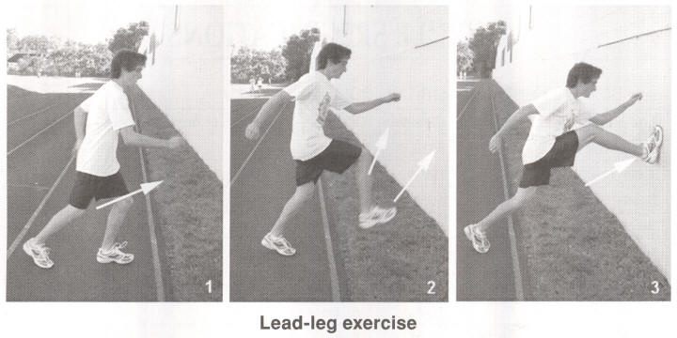

Trail Leg
To teach the correct movement of the trail leg, instruct the athletes to stand with their toes five (of their own) feet from the wall and then lean against the wall with both hands a little above shoulder height. They then place the toes of their trail leg on the ground as far away from the wall as possible and pull the knee of the trail leg forward and up out to the side in a circular motion with the foot following and then pawing the ground slightly ahead of and to the side of the lead-leg foot on the ground. They should do three circular motions with the trail leg, stop, then repeat several times to learn the rhythm.
These two exercises should be incorporated into the warm-up of every workout for beginners in their first year of hurdling.

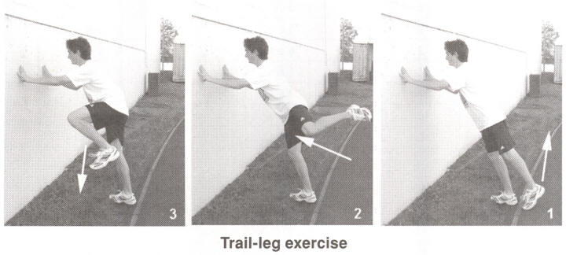

CORRECTING PROBLEMS
Often coaches are presented with the task of re-teaching proper hurdle technique to an athlete who is hurdling incorrectly, whether that athlete is jumping the hurdles, over-striding, swinging the lead leg up, sitting on top of the hurdle, pulling the trail knee through low or a myriad of other faults. Generally the athlete will spend too much time in the air over the hurdles and the following three steps have a dum-da-dum rhythm instead of a quick da-da-da or 1-2-3 action-in other words, a quick, even three-stride action between the hurdles.
To remedy the problem, first reduce the height of the hurdles to a height easily cleared without jumping and reduce the distance between the hurdles so that the athlete does not have to overstride but can run relaxed and quickly. At this point, work on the technique corrections needed.
Once the athlete is sprinting over the hurdles with the correct technique, gradually increase the distance between the hurdles to approach the specified distance for the age group of the athlete. Use four hurdles. Keep looking for relaxed, fast sprinting between the hurdles. Then gradually raise the height of the hurdles (1.5" at a time) until the athlete is hurdling at the specified height for racing.
Be alert to any changes away from a sprinting rhythm. If problems occur with the clearance technique while doing the increases, revert to hurdling over three hurdles set to allow five steps between the hurdles. In this way, the athlete has more time between hurdles to concentrate on the clearance technique for each hurdle.

SHOT PUT
Introduction
Shot put can be contested by any one big, small, short and tall does not matter. What is best is tall quick kids, explosive movements will garner the best results. However any kid can do it ( not just the large ones).
Different kids will pick up the movements at different rates it is important to not try to introduce to much at one time. Make sure a kid understands and can implement the basic techniques before pushing more advanced techniques. The below tasks should be presented to the kids in the order listed and only after they have mastered the earlier tasks. When you start a throwing session always work thru this progression.
Safety
If the shot put hits one in the head it will probably kill that person if they are lucky they would only spend a week in a coma and wake up without brain damage. Kids require close supervision when handling shots even dropping it on one’s foot will splatter the toe. Make sure all your kids are behind the ring and watching the thrower not playing grab ass, a shot can come loose at any time. Always think in terms of safety.
Grip
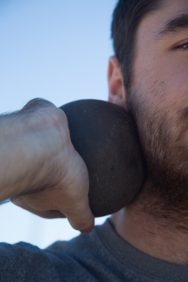
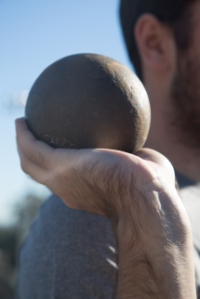
Hold the shot with the fingers mostly closed and nestled at the palm finger juncture. Avoid gripping the fingers and thumb around the shot this makes release difficult ( see fig 1)

Fig 1

Hold
The shot put is held against the neck right under the jaw, elbow up, thumb down (see fig 2). The throw is achieved by pushing it out and up (about 40 deg.) chest hips and chin facing up at this 40deg.. The hardest thing to get across to the kids is pushing the shot, not trying to throw it like a ball. You must have the kids pushing the shot elbow up thumb down before you build upon the technique.
Stance
The stance at the front of the ring for a right handed thrower( all reference is for a righty, mirror image for a lefty) is left foot forward right foot back about 2 shoe lengths apart and split shoulder width. This is known as the power position (see fig 3). While pushing against the ground with the right foot push the shot up and out using the right leg push against the ground following with the arm push make these motions as fluid as possible but maintain the sequence.
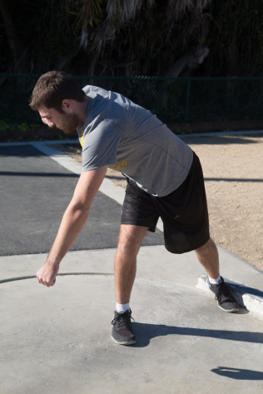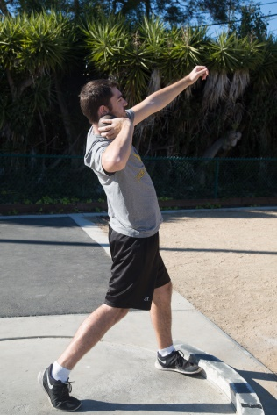
Fig 3 Fig 4

Full Stand Throw
Assume the power position. Now twist the torso to your right, bend the right knee as much as you can down to 45deg., keep the left leg straight pivot the feet 90deg. Clockwise be on the balls of your feet. Holding the shot as discussed. You are now ready to uncork a throw. Using your right foot as a trigger pivot your foot back towards the sector driving your hip up, untwist your torso as your shoulders square up to the sector push the shot out ad up (see fig 4}.

Step Backs
Facing the back of the ring with your right foots toe at the ring and your left foot near the center of the ring, left leg straight, right leg bent at the knee about 90 deg. (see fig 5) Step your right foot back even with your left (see fig 6) than step your left towards the toe board and open you are now at the power position of the full stand throw, make the throw as discussed above. The movements discussed need to stay in order but move fluidly.
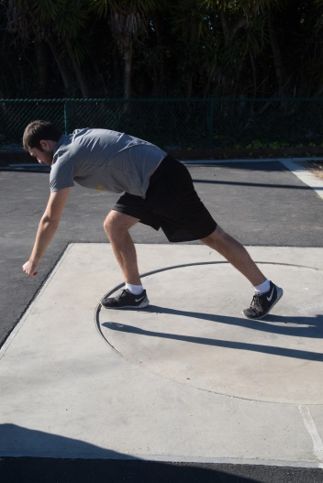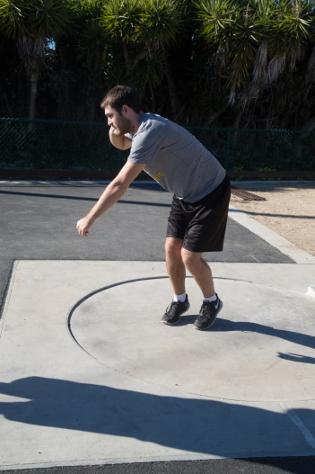

Fig 5 Fig 6
Glide
Like the step backs assume the beginning position. To begin the movements kick the left foot towards the toe board while pushing your body towards the toe board with your right leg/foot. You should be both feet off the ground facing the back of the ring while in the air turn feet counter clock wise, as you land both feet at the same time on the balls of your feet. Landing should trigger the throw in that you should land in the full stand throw position, once again keep the movements fluid.
Rotational Throws
99% of pre high school kids will have extreme difficulty learning the rotational movement and unless you as a coach are extremely knowing of the technique the suggestion would be to not attempt to teach it. If you have great experience with the technique than you are not in need of this tutorial. Regardless safety needs to be observed even more with a young thrower trying to learn the rotational technique, shots will end up flying in all directions.
Warm Ups
Every throwing session needs a appropriate warm up session. If your throwers warm up with the team this is good enough, minimum is a lap and dynamic warm up. Then proceed thru the progression of throws as listed.
Expectations
Kids learn at different rates don’t try to push a kid on to a higher task in the progression until they have mastered the earlier tasks. Some kids will never progress past stand throws in their first season. As a coach if you have never thrown before use you tube and any clinics offered to educate yourself about shot put and other drills associated with shot.

